PIZZA SALES SQL QUERIES
A. KPI’s
1. Total Revenue:
SELECT SUM(total_price) AS [Total Revenue] FROM pizza_sales;

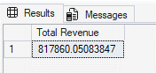

2. Average Order Value:

SELECT SUM(total_price) / COUNT (DISTINCT order_id) AS [Avg Order Value] FROM pizza_sales;

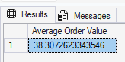

3. Total Pizzas Sold:

SELECT SUM(quantity) AS [Total Orders] FROM pizza_sales;

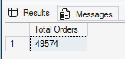

4. Total Orders:

SELECT COUNT(DISTINCT order_id) AS [Total Orders] FROM pizza_sales;

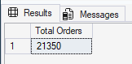

5. Average Pizzas Per Order:

SELECT CAST (CAST(SUM(quantity) AS DECIMAL (10,2)) / CAST (COUNT(distinct order_id) AS DECIMAL (10,2)) AS DECIMAL (10,2))
AS [Average Pizza Per Order]
FROM pizza_sales;

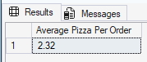

B.CHARTs REQUIREMENT

1. Daily Trend For Total Orders:
SELECT DATENAME(DW,order_date) AS [Order Date], COUNT(DISTINCT order_id) AS [Total Order] FROM pizza_sales
GROUP BY DATENAME(DW,order_date)
ORDER BY [Total Order];

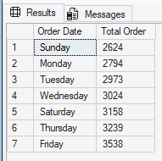

2. Monthly Trend For Total Order:
SELECT DATENAME(MM,order_date) AS [Order Month], COUNT(DISTINCT order_id) AS [Total Order] FROM pizza_sales
GROUP BY DATENAME(MM,order_date)
ORDER BY [Total Order] DESC;

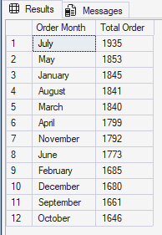

3. Percentage Of Sales By Pizza Category:
SELECT
pizza_category,
CAST (SUM(total_price) AS DECIMAL (10,2)) AS [Total Orders],
CAST (SUM(total_price) * 100.0 / SUM(SUM(total_price)) OVER() AS DECIMAL (10,2 )) AS PCT
FROM pizza_sales
WHERE MONTH(order_date) = 1
GROUP BY pizza_category;
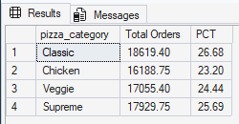

4. Percentage Of Sales By Pizza Size:

SELECT
pizza_size,
CAST (SUM(total_price) AS DECIMAL (10,2)) AS [Total Orders],
CAST (SUM(total_price) * 100.0 / SUM(SUM(total_price)) OVER() AS DECIMAL (10,2)) AS PCT
FROM pizza_sales
GROUP BY pizza_size
ORDER BY PCT DESC;

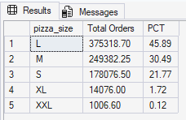

5. Total Pizzas Sold By Pizza Category:

SELECT pizza_category, CAST (SUM(total_price) AS DECIMAL (10, 2)) AS [Total Sales] FROM pizza_sales
GROUP BY pizza_category;

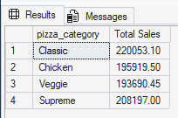

6. Top 5 Best Sellers By Revenue, Total Quantity, and Total Orders:

SELECT TOP 5 pizza_name, CAST (SUM(total_price) AS DECIMAL (10,2)) AS [Total Revenue], SUM(quantity) AS [Total Quantity], COUNT(DISTINCT order_id) AS [Total Orders]
FROM pizza_sales
GROUP BY pizza_name
ORDER BY [Total Revenue] DESC;

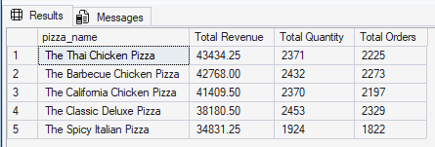

7. Bottom 5 Best Sellers By Revenue, Total Quantity, and Total Orders:

SELECT TOP 5 pizza_name, CAST (SUM(total_price) AS DECIMAL (10,2)) AS [Total Revenue], SUM(quantity) AS [Total Quantity], COUNT(DISTINCT order_id) AS [Total Orders]
FROM pizza_sales
GROUP BY pizza_name
ORDER BY [Total Revenue] ASC;

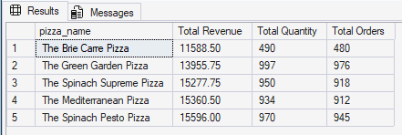

8. Top 5 Pizza By Quantity:
SELECT TOP 5 pizza_name, CAST (SUM(quantity) AS DECIMAL (10,0)) AS [Total Quantity]
FROM pizza_sales
GROUP BY pizza_name
ORDER BY [Total Quantity] DESC;

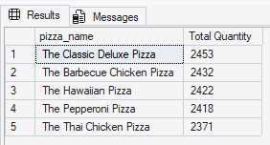

9. Bottom 5 Pizza By Quantity:
SELECT TOP 5 pizza_name, CAST (SUM(quantity) AS DECIMAL (10,0)) AS [Total Quantity]
FROM pizza_sales
GROUP BY pizza_name
ORDER BY [Total Quantity] ASC;

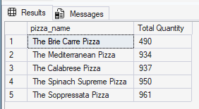

10. Top 5 Pizzas By Orders:

SELECT TOP 5 pizza_name, COUNT(DISTINCT order_id) AS [Total Orders]
FROM pizza_sales
GROUP BY pizza_name
ORDER BY [Total Orders] DESC;

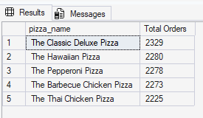

11. Bottom 5 Pizzas By Orders:

SELECT TOP 5 pizza_name, COUNT(DISTINCT order_id) AS [Total Orders]
FROM pizza_sales
GROUP BY pizza_name
ORDER BY [Total Orders] ASC;

